Name: Aarya Tiwari   
Roll Number: 16010421119   
Batch: B1   
Experiment 2   
Title: Jenkins installation

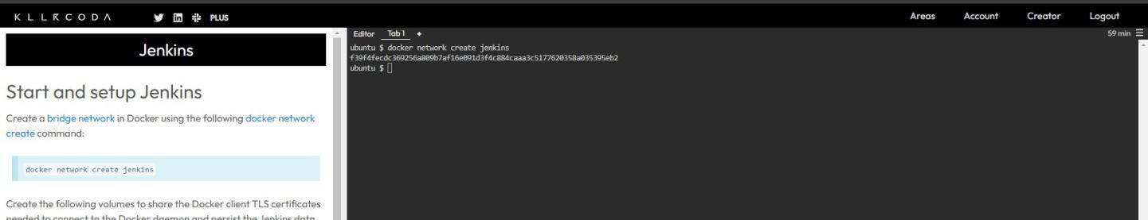

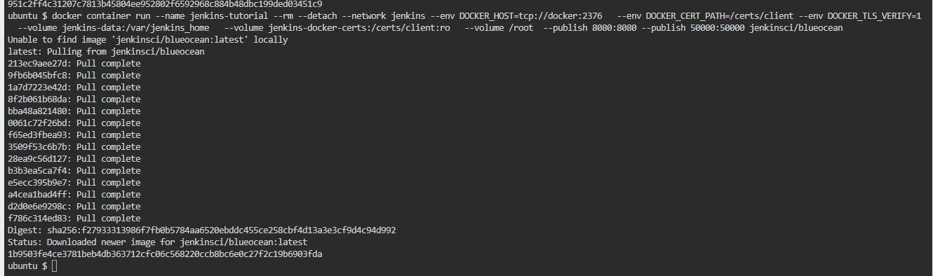

Create a docker network for jenkins

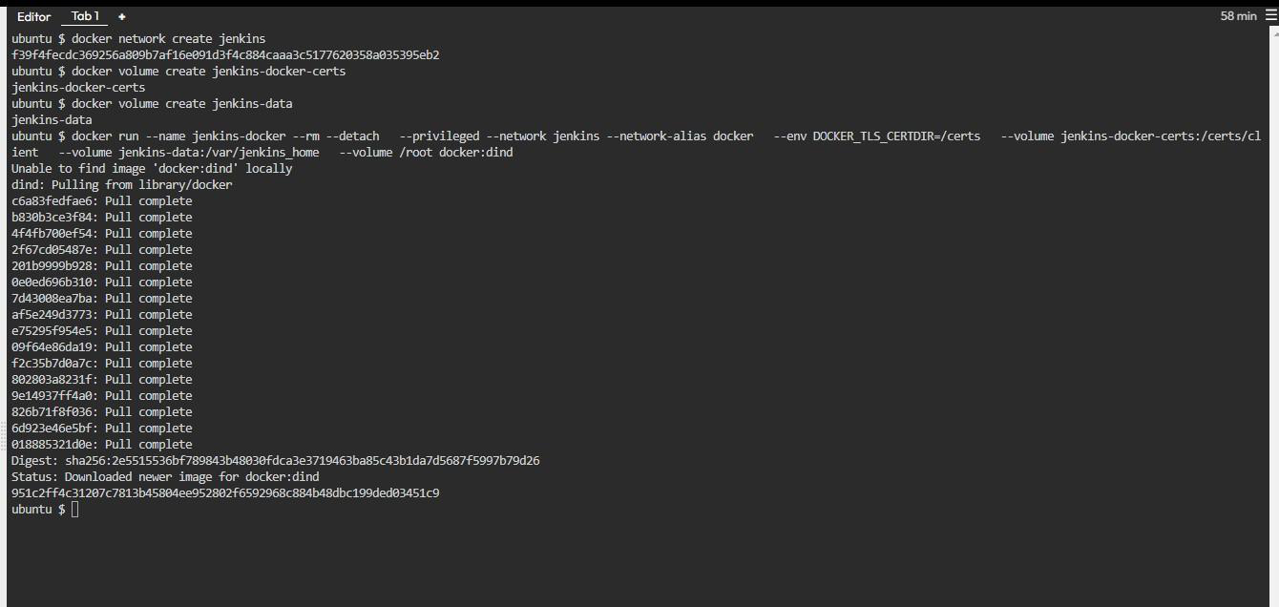

Run docker container for jenkins

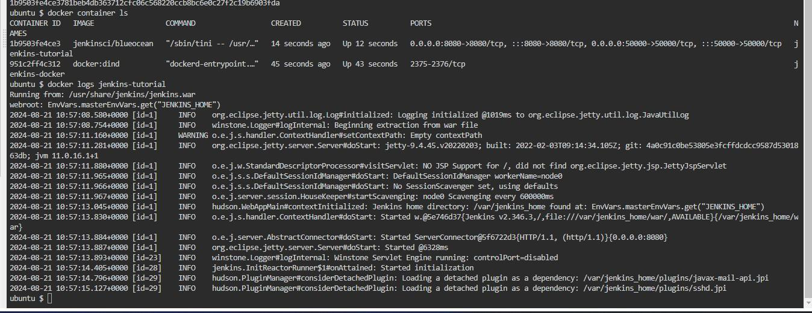

View logs of the docker file

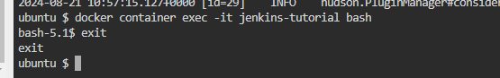

Check Jenkins bash

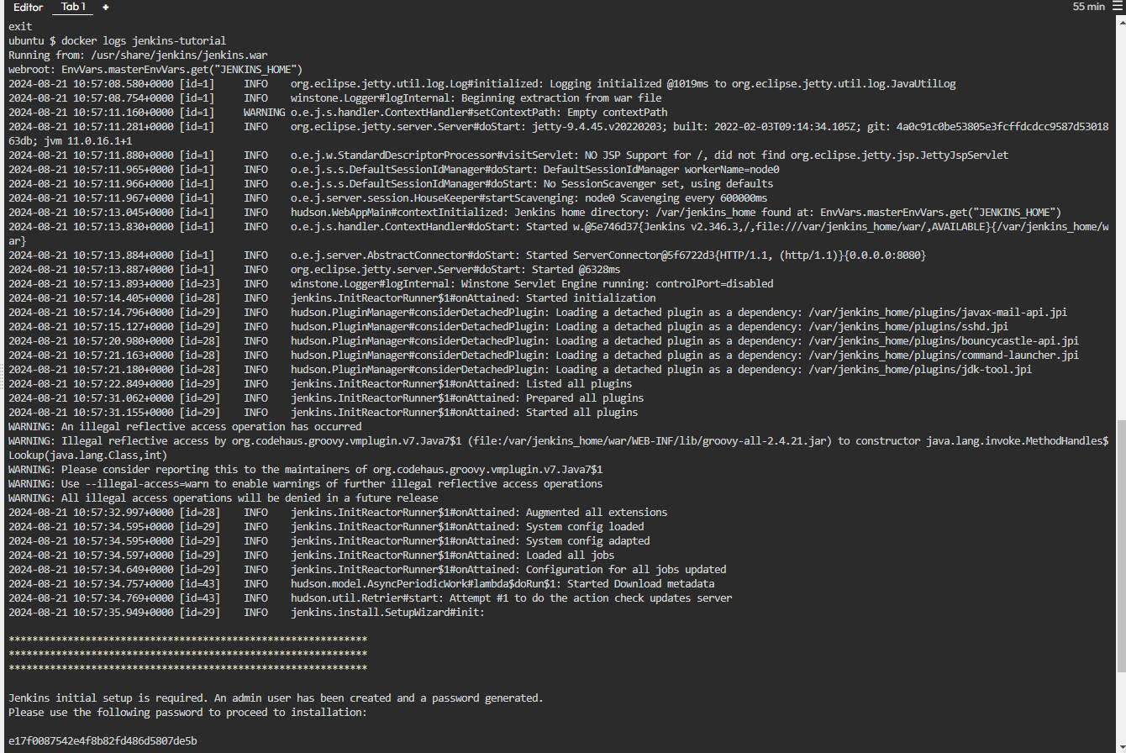

Get password in logs

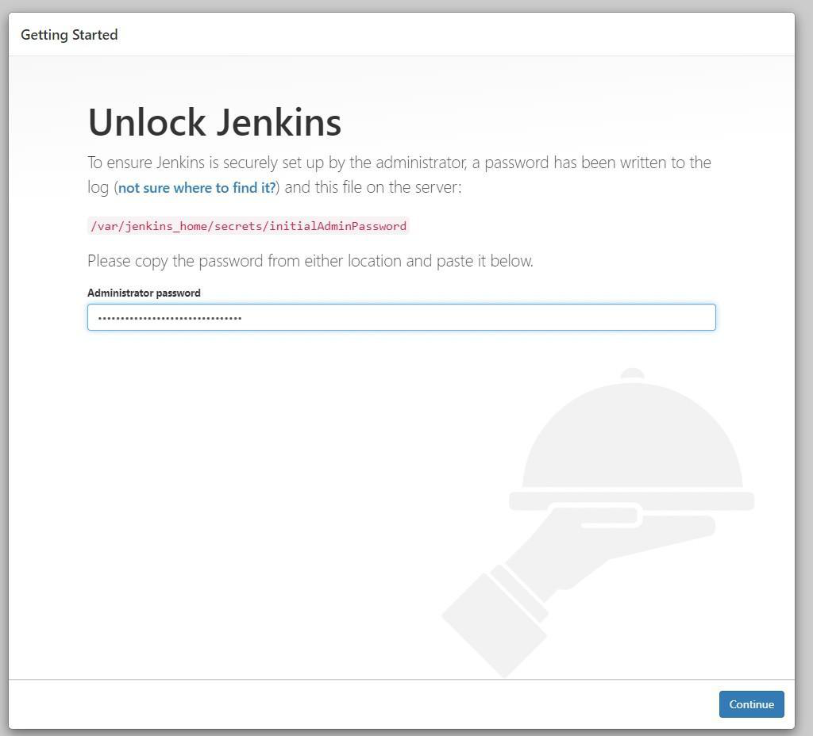

Enter Jenkins password we got in logs   
Docker login- user name, password

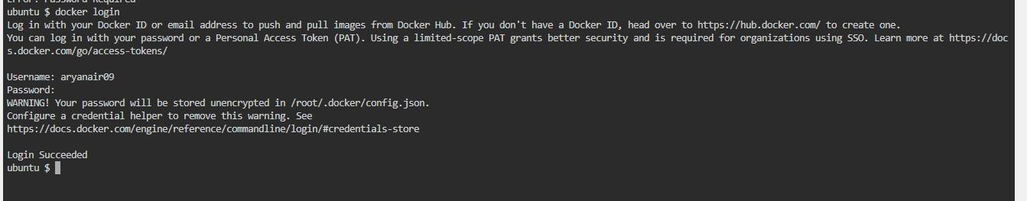

Docker pull “hello-world”0

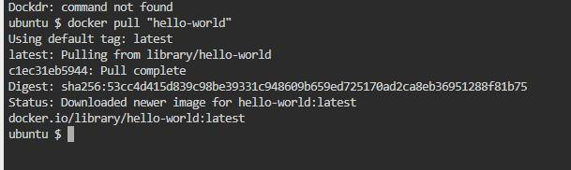

Push image to docker

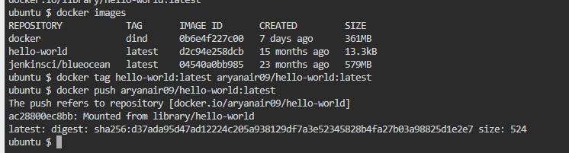

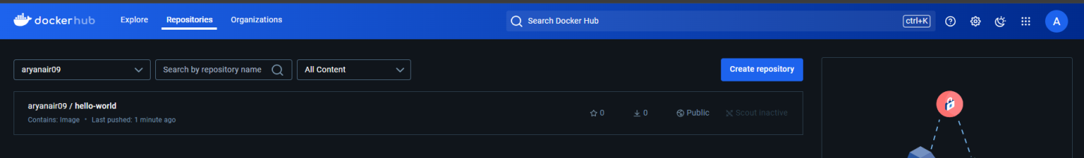

Push image to docker



Run docker image

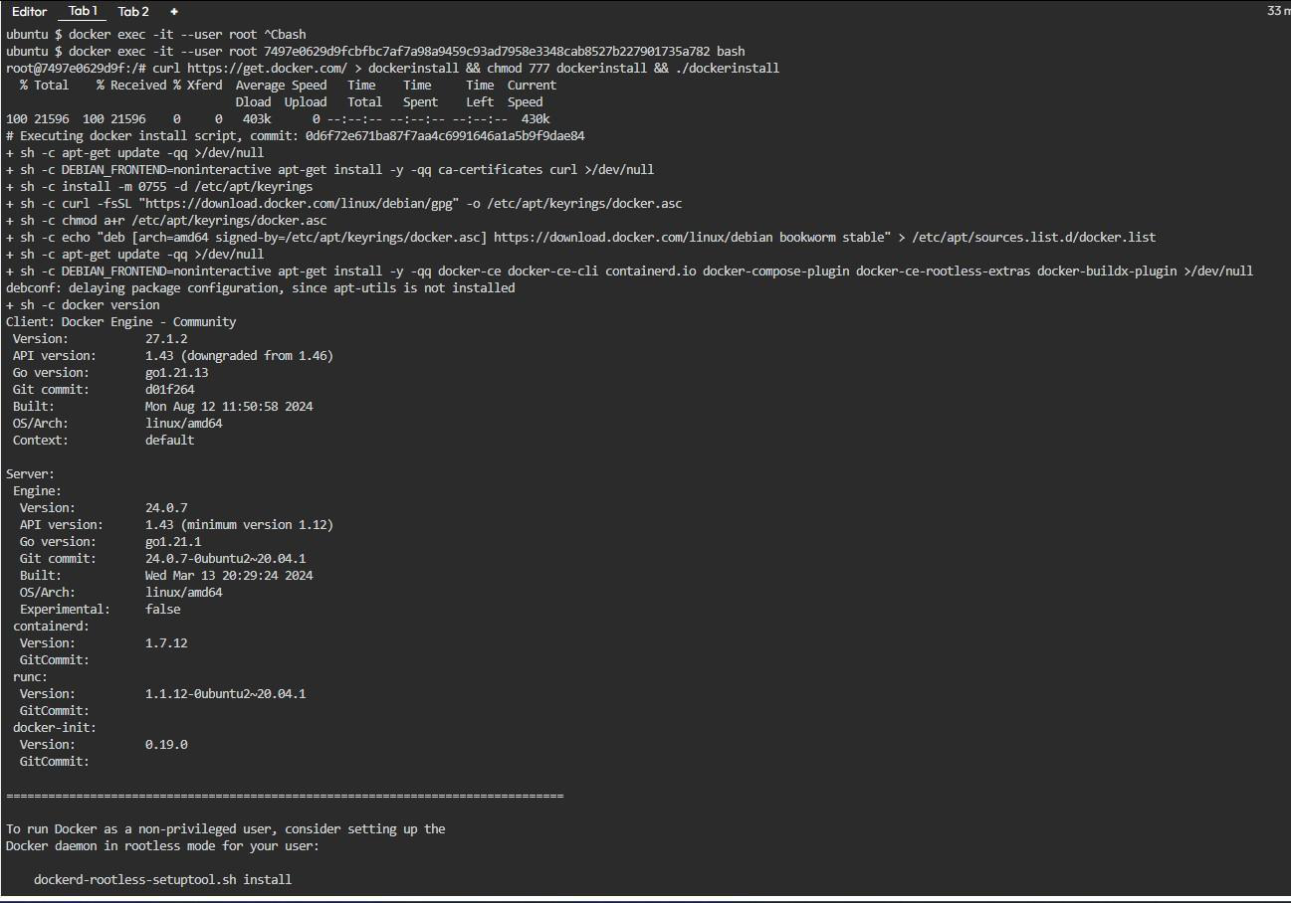

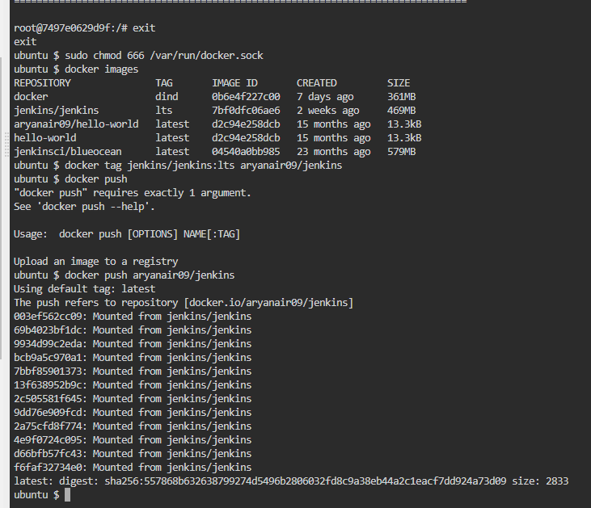



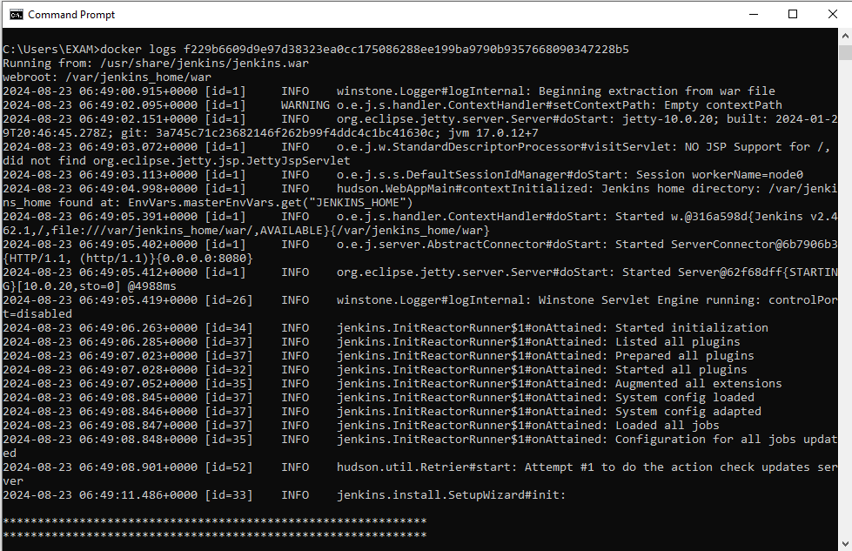

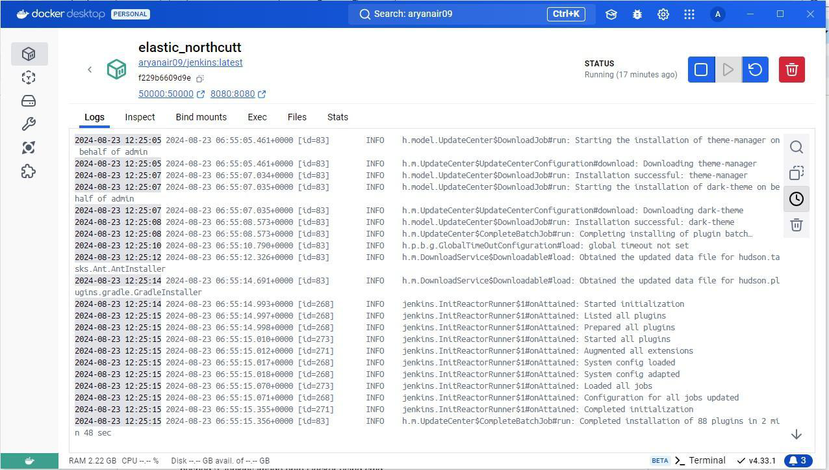

Docker container running in docker desktop

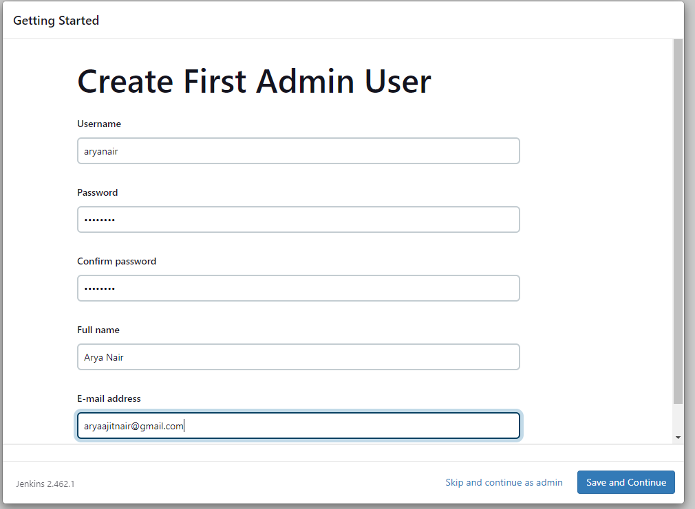

Create admin user

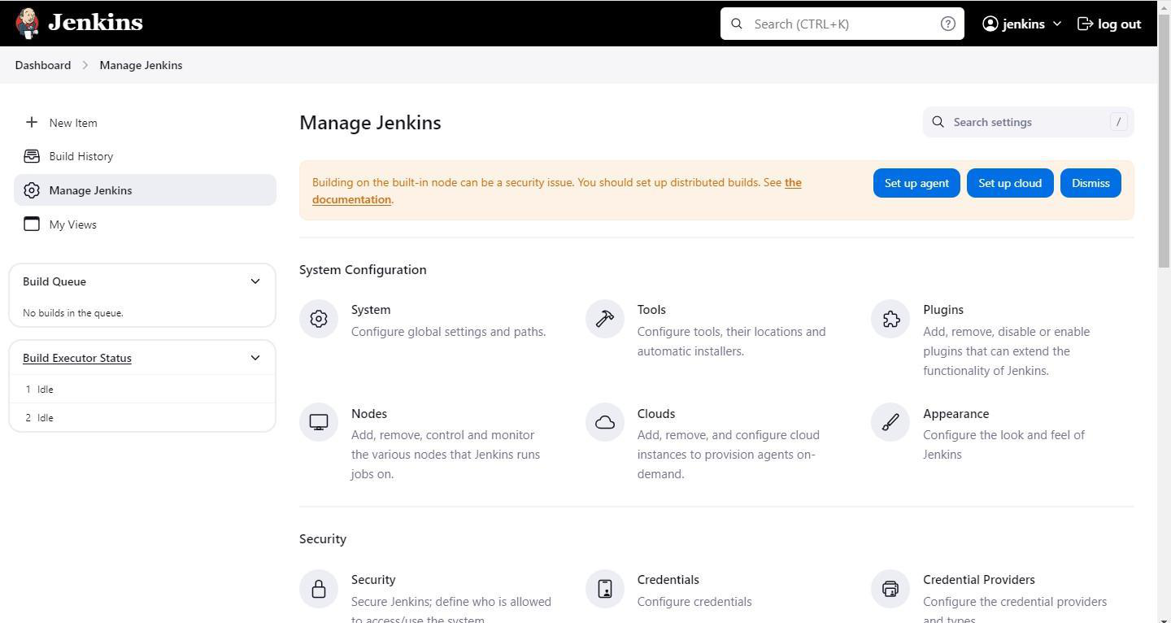

Enter jenkins

POSTLAB Questions

|  |  |
| --- | --- |
| ● | Explain various options/features of Jenkins dashboard |

**Ans:**

Jenkins is an open-source automation server used to automate the parts of software

development related to building, testing, and deploying, facilitating continuous integration and

continuous delivery (CI/CD). The Jenkins dashboard provides a central interface for managing

and monitoring jobs, pipelines, and other tasks. Here’s a breakdown of various options and

features of the Jenkins dashboard:

● Dashboard Overview

● Main Dashboard: Shows a list of all jobs/projects with their current status (e.g.,

success, failure, in progress).

● Search Bar: Allows you to quickly find jobs, pipelines, or other items within Jenkins.

● User Menu: Located at the top-right corner, this menu includes options like

“Logout,” “Configure your profile,” and “Manage Jenkins.”

● Job/Pipeline Status Indicators

● Color Codes: Jobs are indicated by colors (e.g., blue for success, red for failure,

yellow for unstable, gray for disabled).

● Weather Icons: Provide a quick visual summary of the job's recent success/failure

rate (e.g., sunny for consistent success, stormy for frequent failures).

● Build Queue

● Displays jobs that are waiting to be executed. You can view the priority, status, and the

build executor that is running a job.

● Build Executor Status

● Shows the status of each executor (whether it's idle or busy) and which jobs are

currently being executed.

● Side Panel Options

● New Item: Create a new job or pipeline. You can select the type (e.g., Freestyle

project, Pipeline, Multibranch pipeline) and configure it.

● People: Lists all Jenkins users and their recent activity.

● Build History: Shows a chronological history of builds across all jobs, including

timestamps and statuses.

● Manage Jenkins: Admin panel for configuring global settings, installing plugins,

managing nodes, and more.

|  |  |
| --- | --- |
| ● | My Views: Allows users to create custom views for organizing jobs and |

pipelines according to specific criteria.

● Credentials: Manage credentials used in Jenkins, such as SSH keys, tokens,

and passwords.

● Configure Jenkins: Global configuration for setting up system-wide configurations

such as JDK, Maven, and security settings.

● System Log: Displays logs for Jenkins activities, useful for troubleshooting.

● Script Console: Advanced feature where you can run Groovy scripts to

perform administrative tasks.

● Job/Pipeline-Specific Features

● Configure: Allows you to set up or modify the configuration of a specific job/pipeline,

including source code management, build triggers, build steps, and post-build

actions.

● Build Now: Manually trigger a build for the job or pipeline.

● Workspace: View and manage files and directories created during the build process.

● Polling Log: View logs related to source code polling activities.

● Console Output: Displays the output from the most recent build, including all logged

messages and errors.

|  |  |
| --- | --- |
| ● ●  ● ● ● | View as Build Pipeline: Visualize the stages of the build pipeline. Delete Project: Removes the project from Jenkins.  Views  List View: The default view showing all jobs in a list.  Build Pipeline View: Displays the pipeline of jobs as a visual flowchart, making it |

easier to understand the flow from one job to the next.

● Dashboard View: A customizable view that can include different widgets like status

summaries, build statistics, etc.

● Plugins and Integration

● Plugin Manager: Install, update, or remove plugins that add additional features

and integrations to Jenkins.

● Global Tool Configuration: Configure global tools like JDK, Git, Maven, etc., which

can be used by all jobs.

**Outcomes:**

**CO4:** Explain code deployment and monitoring systems and their tool support.

**Conclusion (based on the results and outcomes achieved):**

In completing this experiment, I successfully installed Jenkins and Docker for Windows and pushed a Jenkins image onto Docker using cmd.